**Creating NODE-RED Service**

* Node-RED is a flow-based development tool for visual programming developed originally by IBM for wiring together hardware devices, APIs and online services as part of the Internet of Things.

|  |  |
| --- | --- |
| **Team ID** | **PNT2022TMID08806** |
| **Project Name** | **Project -Hazardous area monitoring for industrial plant powered by IoT** |

* 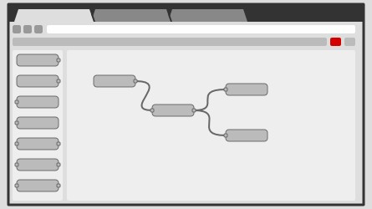Node-RED provides a web browser-based flow editor, which can be used to create JavaScript functions. Elements of applications can be saved or shared for re-use.
* The runtime is built on Node.js.
* The flows created in Node-RED are stored using JSON.

**Social Development:**

* The flows created in Node-RED are stored using JSON which can be easily imported and exported for sharing with others.
* An online flow library allows you to share your best flows with the world.

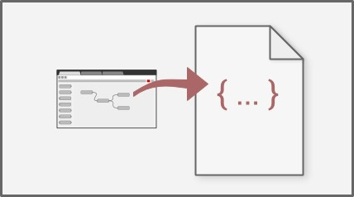

**Step1:** go to node.js website and download.msi file in downloads page.

**Step2:** run the.msi file and install the node.js

**Step3:** install node red in command prompt : npm install -g -unsafe- perm node-red

**Step4:** type node-red in cmd and u will get the local server link, just open it.

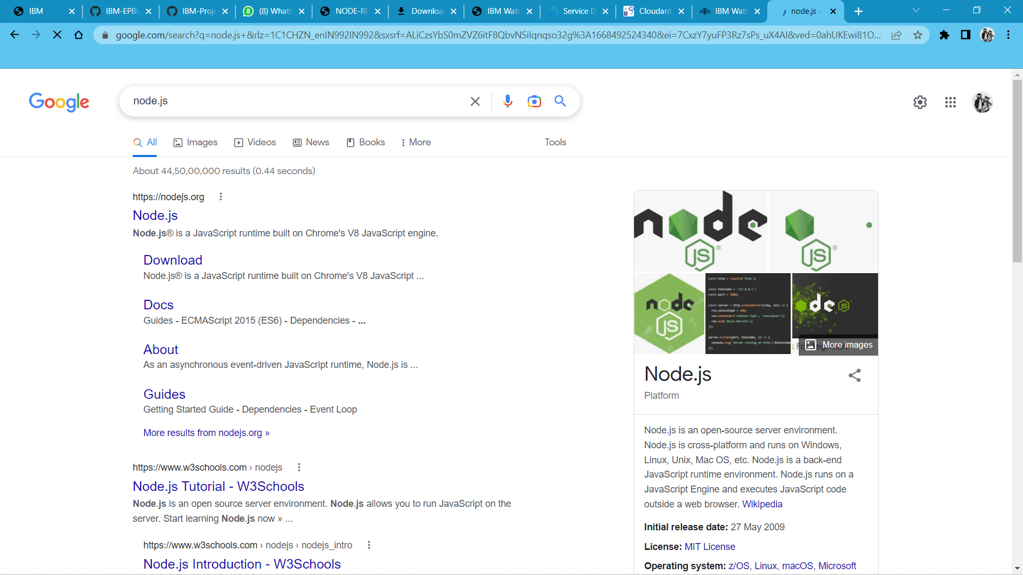

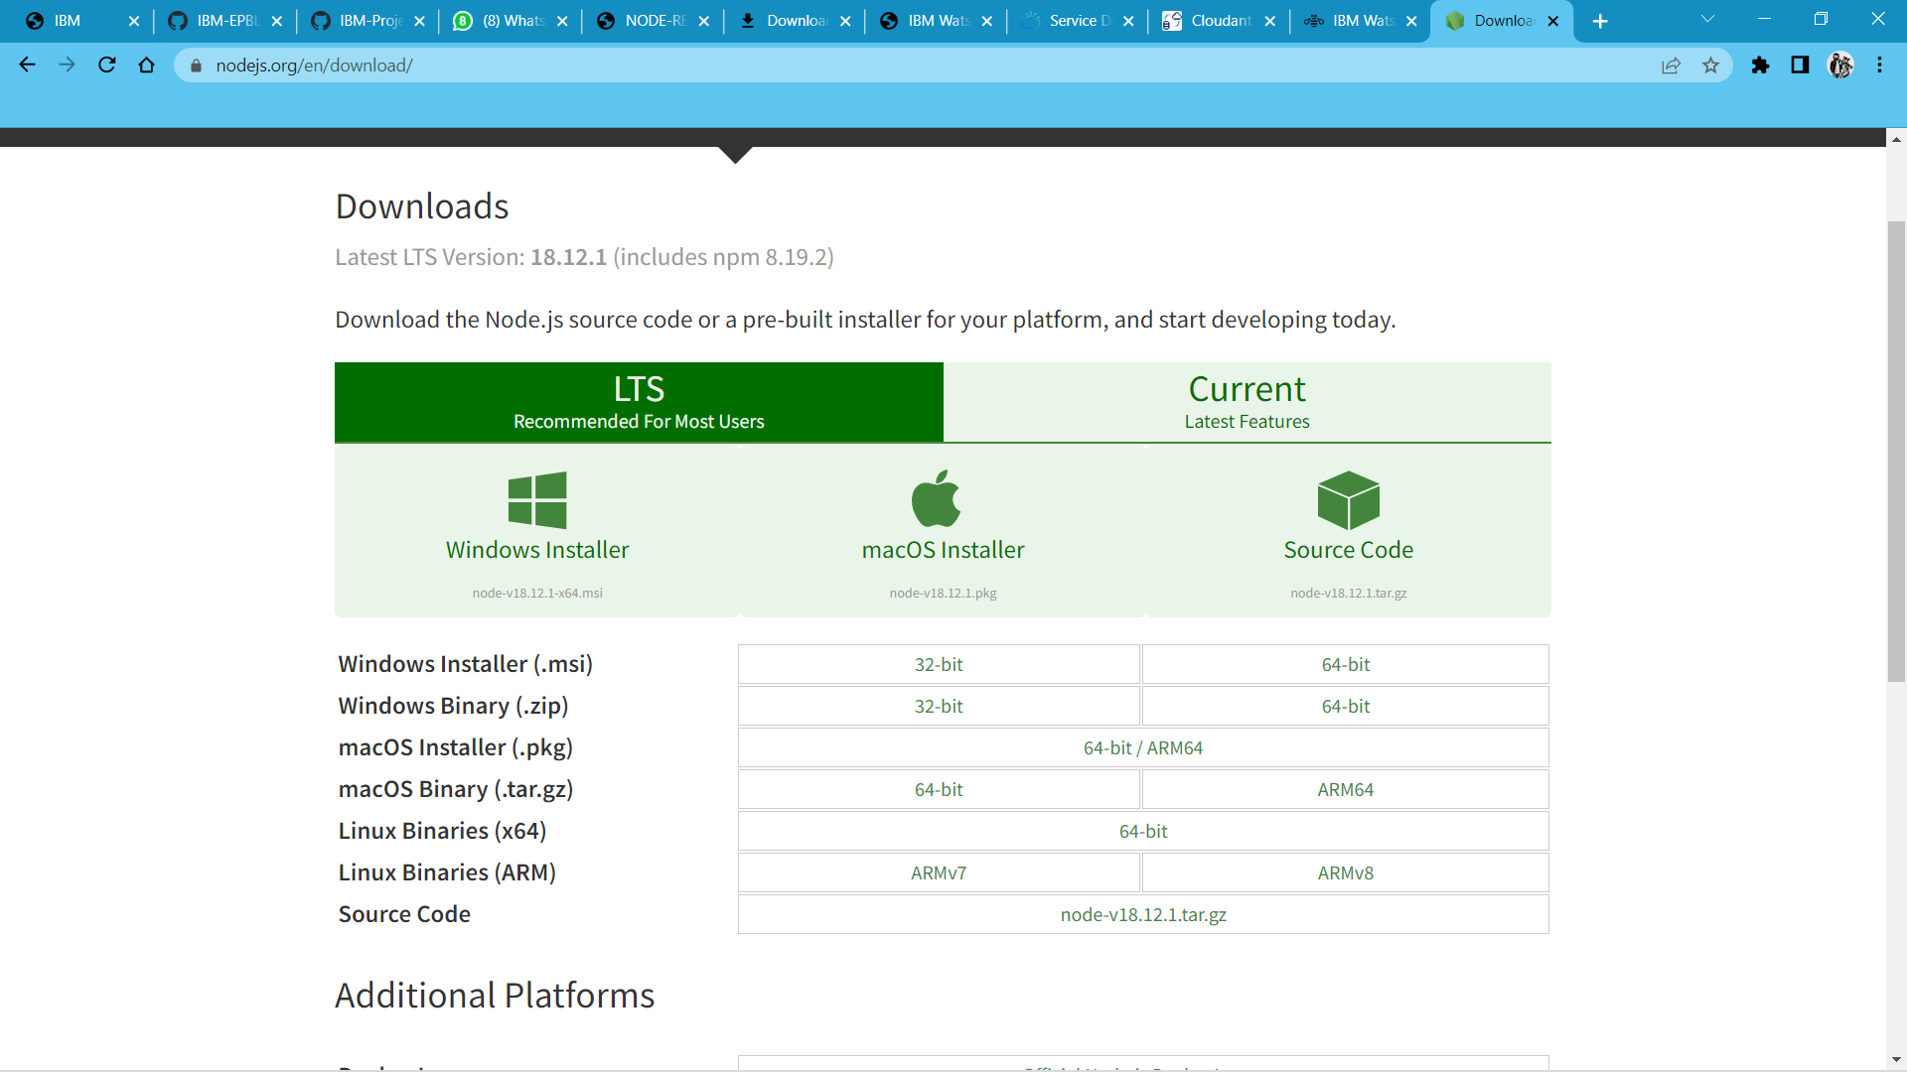

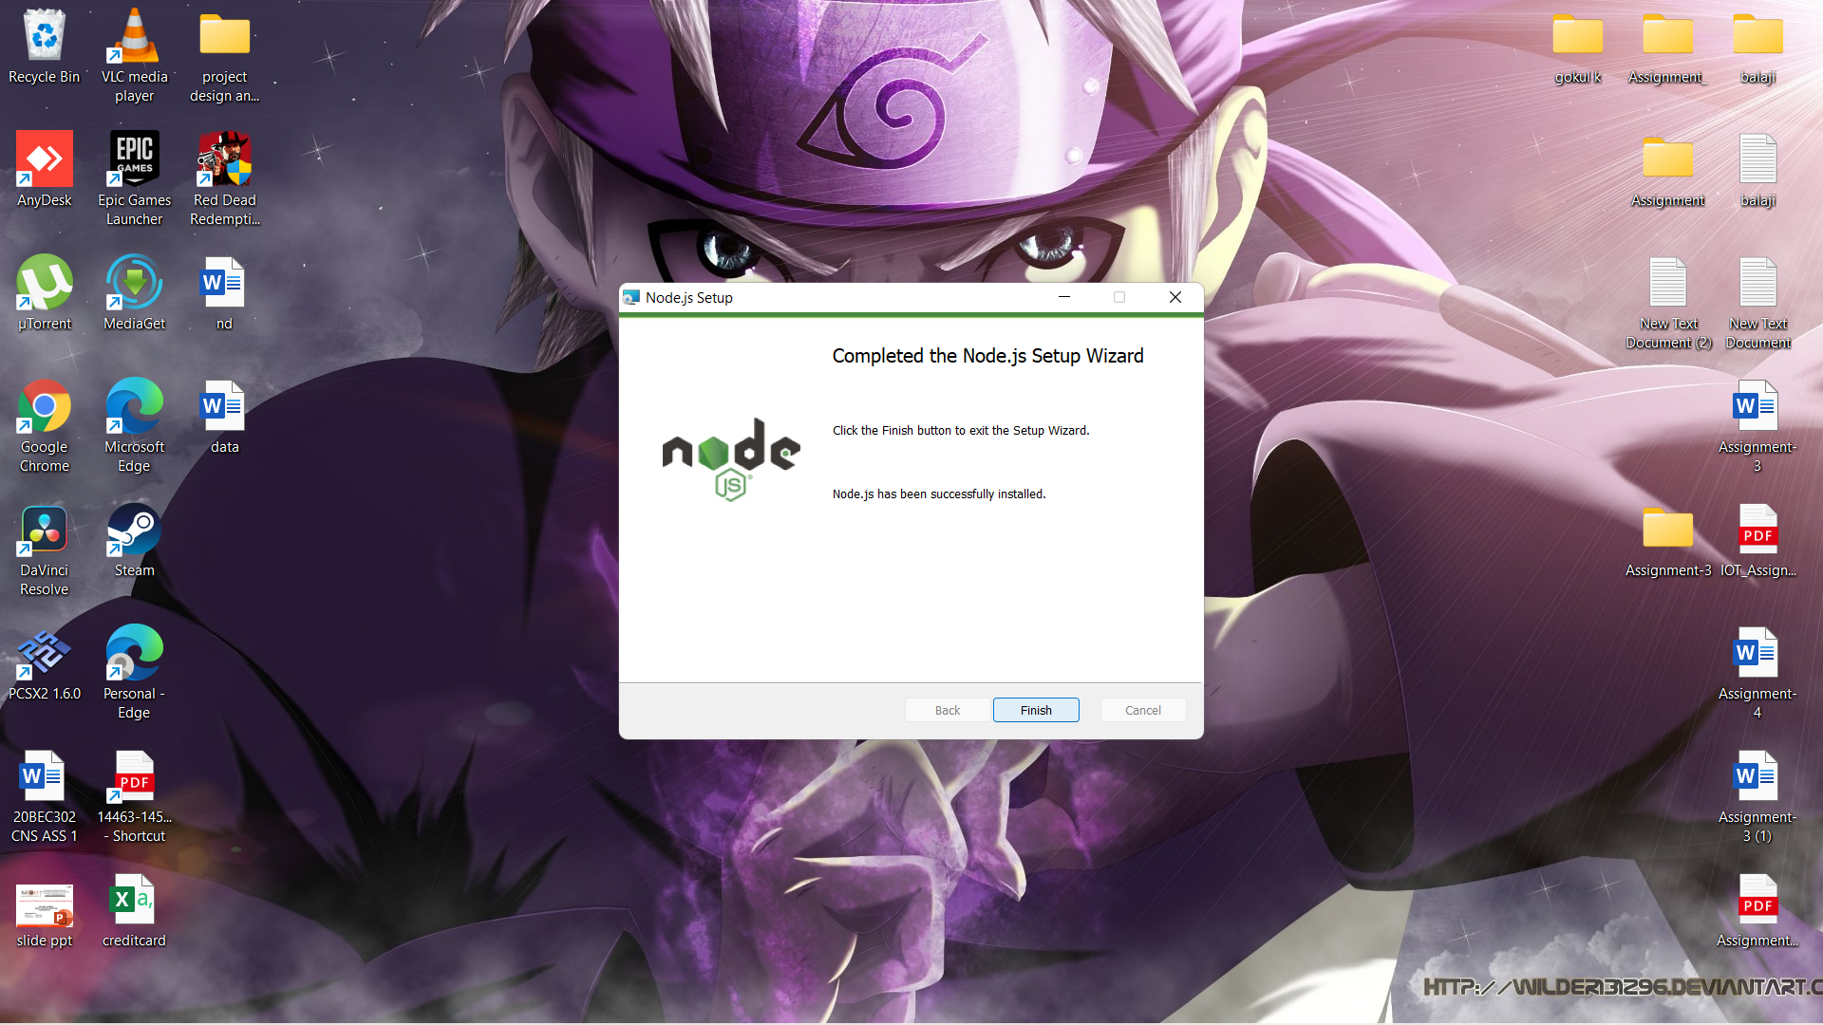

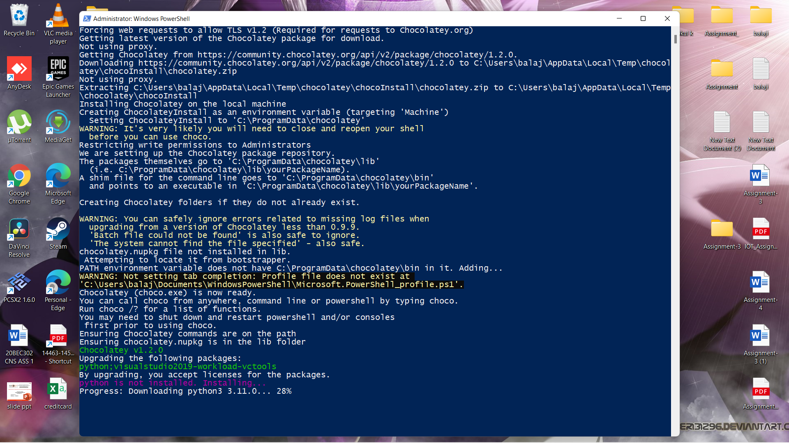

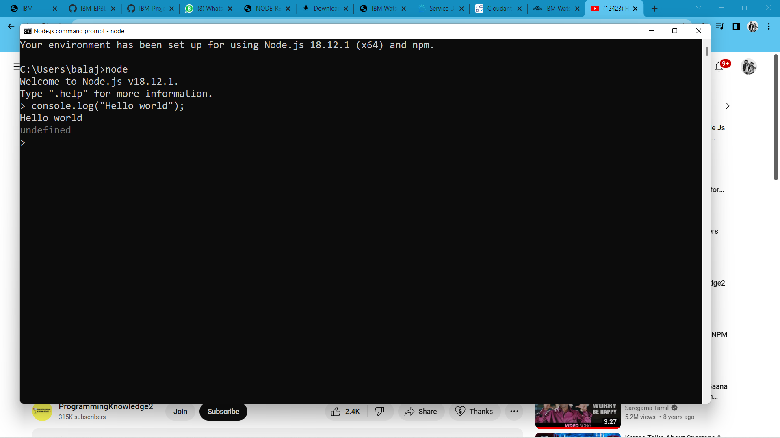

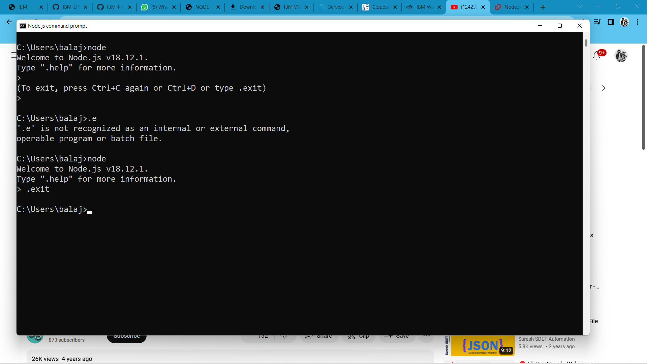

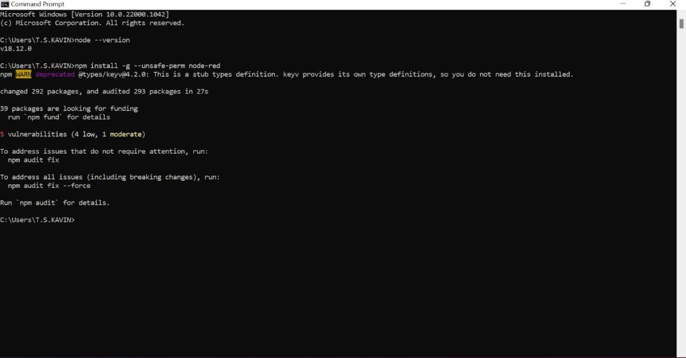

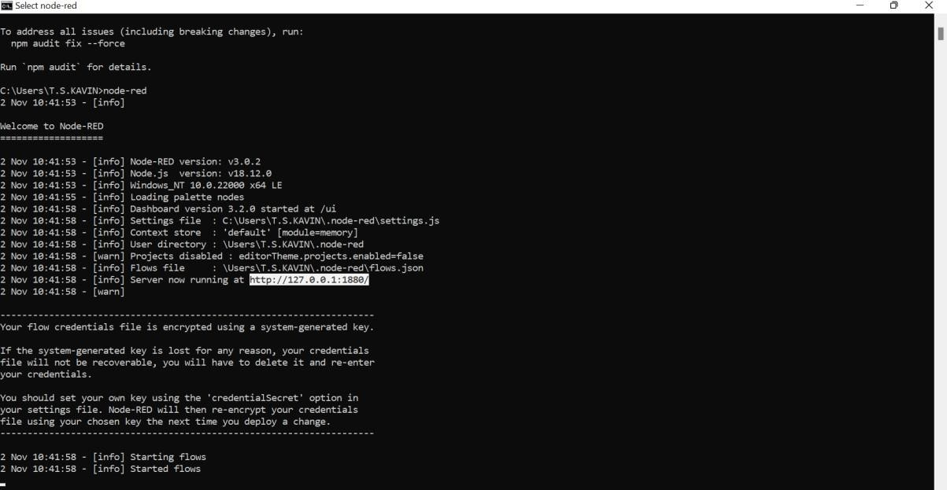



**Thus we created NODE-RED Service.**